SHED NO 27, SHUBHAM INDUSTRIAL ESTATE, NR. TORENT POWER SUB STATION, KATHWADA GIDC, AHMEDABAD – 382430
GST NO: - 24ARDPD2565K1ZX

info@torqpackagingsolution.com
www.torqpackagingsolution.com

Quotation No-111

DATE: - 25-8-2025
To,
M/S: DAXA BEN NIRAMAL SINH ZALA
PEDHMALA,SABARKANTHA,GUJARAT

SUB: - AUTOMATIC GHEE POUCH PACKING MACHINE.

Dear Sir,
Many thanks for your valuable inquiry of above subject. TORQ PACKAGING Solutions Is engage in making preliminary Bottle Packaging machines like bottle filling , capping , labeling, Automation, etc… in Ahmedabad, We are having dedicated team for manufacturing, customized machine development, Sales, servicing and back office.

Thanks & Regards
Ronak Dave
+91 8000032128

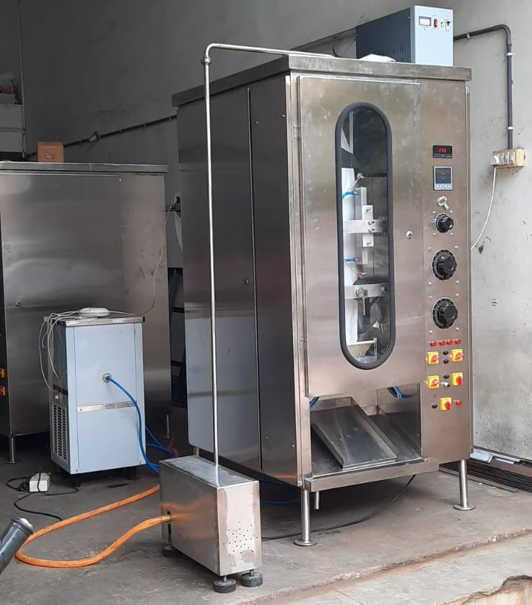

Sr.No | Description | Qty | Unit Rate
1 | Model: TPS-PP-O4 (250 to 500 ml)  Scope of Supply along with Machine:  - Photo Mark Sensor with fittings  - Positive displacement Pump with Motor  - 5 kva stabilizer  - 20 ltr chiller  - Mechanical batch coading | 1 | 3,50,000/-

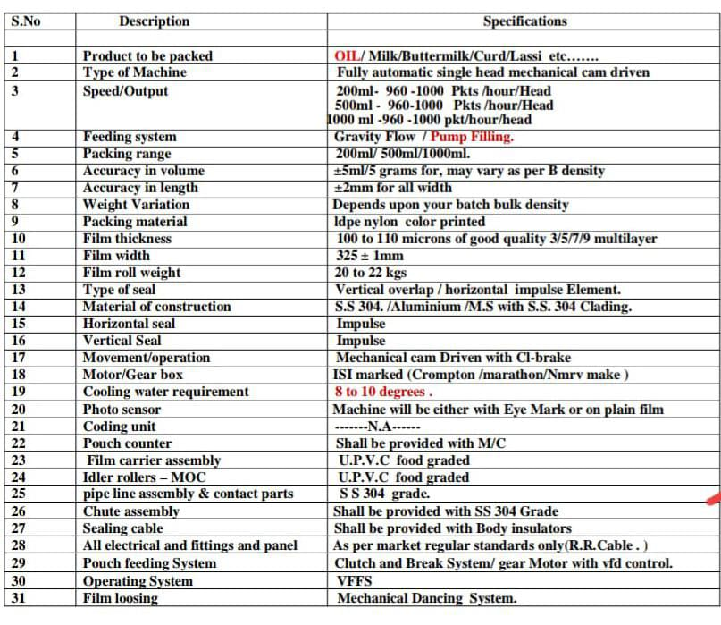

Price Breakup
S.N. | PARTICULERS | CAPACITY | QTY | AMOUNT
1 | Automatic oil pouch packing machine. | 250 TO 500 ML | 1 | 3,50,000/-
 | BANK DETAIL :  Account name :- TORQ PACKAGING SOLUTION  Account number :- 8000032128  Bank name :- KOTAK MAHINDRA BANK LTD  Branch :- KATHWADA  IFSC :- KKBK0002606  COMPANY GSTIN : 24ARDPD2565K1ZX | TOTAL |  | 3,50,000/-
 |  | IGST @ 18% |  | 63,000/-
TOTAL AMOUNT |  |  |  | 4,13,000/-
TERMS & CONDITIONS |  | For, TORQ Packaging Solution  
- 50 % Advance on Signing up of Contract
- 50% On Completion of Machinery Manufacturing Before Dispatch / During Inspection of machinery
- Order Once Placed Cannot be Cancelled
- No Refund will be entertained

- Terms & Conditions

1 | PRICE | The prices mentioned are ex our Ahmadabad works including wooden box packing
2 | TAXES & DUTIES | (domestic only)
3 | TERMS OF PAYMENT | We agreed to have 50% advance and 50 % before Dispatch.
4 | DELIVERY  PERIOD | Within 3-4 Weeks from the date of receipt of technically & commercially clear order along with advance payment or receipt of approval for input dimensions, whichever is later
5 | INSURANCE | Transit Insurance against Theft, Pilferage, Breakage, Etc. will be arranged at extra cost at your explicit instruction, otherwise it will be assumed that goods are to be sent at your risk. Cost of such insurance will be as actual to be borne by the consignee.
6 | TRANSPORT | Transportation of the machine from our factory has to be arranged by you. We will arrange for loading of the equipment at our factory. However unloading at site has to be arranged by you. Our responsibility ceases once the goods leave our factory and are handed over to carrier. We do not undertake any liability for damage/ loss in transit whatsoever, whether the goods are insured or not. In case of any damage / accident during transit, the client has to directly deal with the insurance company without holding any payments, irrespective of the insurance arranged by Consigner or Consignee.
7 | INSPECTION | We offer inspection of the machine at our factory, by your technically competent representative, prior to dispatch. This person should be present on our factory during packing and loading of the machine. In case you are not deputing anyone for pre dispatch inspection, then we will not entertain any dispute arising out of short supply, quality, workmanship, functionality, operating parameter, etc. once the machine is dispatched.
8 | FACTORY  TRAINING | We will impart training to your operating staff in our factory before the machine is dispatched, at no additional cost. However, his lodging-boarding and local traveling expenses will have to be borne by you. This person should be technically competent to uncrate and assemble the machine at site before the arrival of our commissioning engineers. He must ensure that ground work necessary at site is competed in all respects before machine. Commissioning, He must be competent enough to be able to run the machine and carry out routine maintenance, once the machine is handed over after commissioning
9 | INSTALLATION | The machine has to be uncarted and placed in working position by you at site. You have to carry out all the external powers and air compressor at site. The machine must be available in the fully assembled condition when our commissioning engineer arrives at site.
10 | COMMISSIONING | For supervising and commissioning of the machine we will depute one of our engineers on chargeable bases. Customer will have to send a prior intimation of readiness of electrical and utility connections along with required materials.  Rs. 2,000/- per man day will be charged. Customer will reimburse to and for 1st class fare from  Ahmedabad to the destination, lodging and boarding expenses and other local expenses for the period of commissioning.
11 | SPECIFICATION | In line with our policy of continual improvements, we reserve The right to modify the design and change the specifications and make of any material, if in our opinion such modification leads to an improvement in the performance of the machine. Therefore specification, illustrations, dimensions, offers, drawings or photographs are not binding in detail.
12 | WARRANTY | Our goods carry a warranty of one-year trouble free operation from the date of dispatch. The warranty is only against manufacturing defect. It does not cover any electrical, electronic or bought out components.  Components getting normal wear and tear would be replaced at your cost.
13 | NOTE | Customer have to provide samples of bottles, caps, labels etc. along with the purchase order otherwise machine will be made as per our standard specifications, wherein we will take trial with water, caps, bottle, label etc available with us, which will be acceptable to you.
14 | CANCELLATON  OF ORDER | Order once placed, cannot be cancelled under any circumstances. In case of orders being cancelled, then the entire amount of advance payment will stand forfeited.
15 | OFFER VALIDITY | This offer remains valid for the period of 30 days. Any extension thereafter will be subject to our written confirmation only.
16 | JURISDICTION | No legal proceedings shall be taken to enforce claims and no suit arising out of any contracts shall be instituted except in a court of competent jurisdiction located within Ahmedabad, Gujarat.

